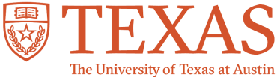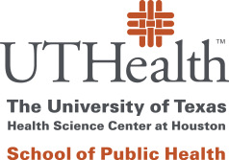

**TOPICS IN TRANSLATIONAL SCIENCE**

**RELEASE FORM FOR AUDIO-VIDEO RECORDING**

I voluntarily give my permission for staff and/or faculty from The University of Texas Health Science Center at San Antonio/UT Health San Antonio, The University of Texas at Austin, and/or The University of Texas at San Antonio to record my image and/or voice on video and/or audio recordings of the Topics in Translational Science course.

I understand that some classes in this course will be recorded and posted for access by course participants and other stakeholders at a later time. It is possible that my image or voice will be captured during these recordings. While the primary intent of the recordings is to provide students with supplemental access to the content of the class, I also authorize use of my image and/or voice obtained in these recorded sessions, in whole or in part, in electronic or print mediums, such as university websites, magazines, brochures, newsletters, the Internet, and social media, for educational and publicity purposes as deemed appropriate by the Institute for Integration of Medicine and Science (IIMS) and other authorities of the participating universities.

I understand that I may withdraw or revoke my authorization at any time and such revocation must be given to the Topics in TS course director in writing. If I withdraw my permission, my image/information may no longer be used or released for the reasons covered by this authorization; however, I understand that any release made prior to a revocation may remain in public domain.

|  |  |
| --- | --- |
| **PRINTED NAME:** |  |
| **SIGNATURE:** |  |
| **DATE:** |  |